Name : GOKUL BARADWAJ C
REG. NO. : 192512073
Simulation and Throughput Analysis of LTE-Advanced Carrier Aggregation
Objective 1:
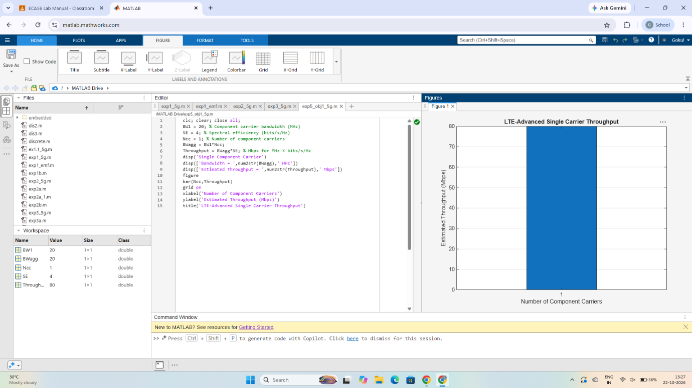

Objective 2:
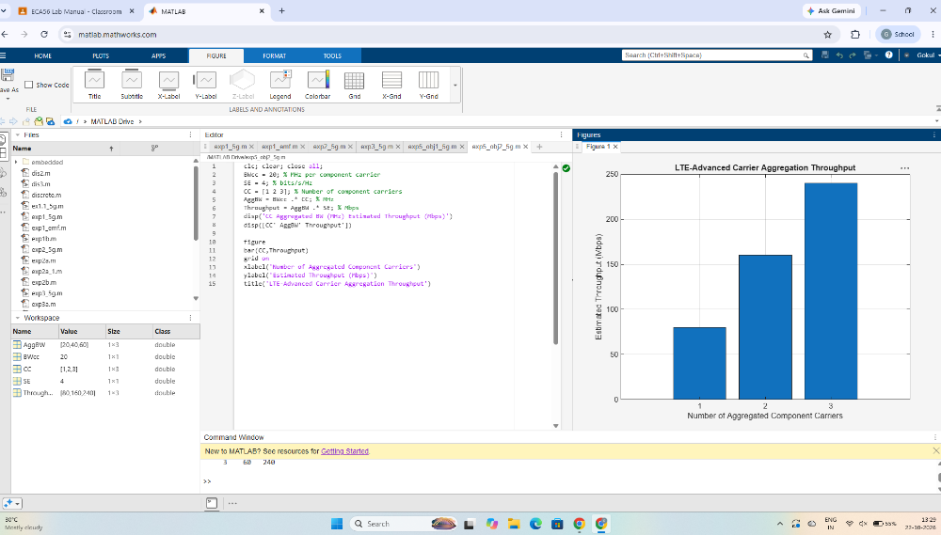
Objective 3:
